DriverPass Business Requirements Document
Charles Kwena • CS 255 Project One • Portfolio copy
Prepared from the DriverPass client interview and course template. Technical controls labeled as recommendations are proposed design choices, not confirmed client requests.

System Components and Design

Purpose
- The client is DriverPass, represented by owner Liam and IT officer Ian. The company wants to help customers prepare for DMV driving tests through classroom instruction, online learning and on-road training.
- Design a web-accessible system supporting enrollment, account management, reservations, practice tests, lesson notes, reporting and permissions.

System Background
- DriverPass is responding to students who struggle with driving tests. Customers need convenient training and scheduling, and staff need a central location for operational records.
- Major components: customer portal; secretary/employee portal; role and account administration; lesson scheduling with drivers and cars; package enrollment; learning and practice test progress; DMV update notifications; reporting/audit history; cloud-hosted database.

Objectives and Goals
- Offer three packages: Package One has 6 driving hours; Package Two has 8 hours plus an in-person DMV rules lesson; Package Three has 12 hours plus the in-person lesson and online class/practice tests.
- Support exactly two-hour driving sessions and associate each reservation with a customer, driver, car, time, pickup/drop-off location and responsible account.
- Allow customers to create, modify and cancel appointments online; allow the secretary to schedule for customers by telephone or in person.
- Track practice-test name, duration, score and status (not taken, in progress, failed or passed), along with driver comments and lesson start/end times.
- Support printable activity reports and downloadable reports for offline Excel work; database updates should occur only while connected.

Requirements

Nonfunctional Requirements

Performance Requirements
- The system must run in a web browser on computers and mobile devices; expected user volumes and response-time service levels require confirmation.
- DMV training content should be updated when official changes become available; the method and frequency of that connection require confirmation.
- Proposed design: provide prompt booking conflict messages and managed cloud availability/backup monitoring; define testable performance targets with DriverPass before development.

Platform Constraints
- Cloud-hosted browser application with a central database rather than multiple disconnected local datasets.
- A managed cloud provider should handle backups and core hosting security because DriverPass does not want to operate its own infrastructure.
- The specific operating system, database platform, payment processor and DMV integration are not designated by the client and should be selected during technical design.

Accuracy and Precision
- Each user receives a unique login/account and permissions appropriate to their role. Record the actor and timestamp for reservation creation, editing and cancellation.
- Validate required registration fields and enforce two-hour sessions, matching pickup/drop-off locations, and no conflicting driver or car allocations.
- Input case-sensitivity and alert thresholds are design decisions needing stakeholder approval; emails can be normalized for login while passwords remain case-sensitive.

Adaptability
- Ian needs administrator access to reset accounts, block former employees and manage permissions.
- Liam must be able to disable an existing package to prevent new signups. Adding/removing modules or restructuring packages is outside the initial release and would require development.
- Proposed design: configurable roles/status flags and documented change procedures to reduce future maintenance.

Security
- Authenticate users and authorize actions by role; customers may see their own records and authorized staff may see only records needed for their work.
- Provide secure self-service password reset for customers, and IT-managed resets and account blocking for staff.
- Proposed security controls: HTTPS, hashed/salted passwords, rate limiting or temporary lockout against guessing, activity logging and managed backups.
- Customer payment details are sensitive. Although the interview requests credit card number, expiry and security code on registration, recommend an approved payment provider and avoid storing card security codes. Confirm handling requirements with the client.

Functional Requirements
- The system shall provide account registration, login and password reset for customers.
- The system shall record a customer’s name, address, state, phone, pickup/drop-off location and authorized payment information.
- The system shall display Packages One, Two and Three with the training included and permit enrollment in available packages.
- The system shall allow authorized management to disable a package for new enrollments.
- The system shall let customers reserve, reschedule and cancel two-hour driving appointments through their accounts.
- The system shall allow the secretary to create and change customer appointments on their behalf.
- The system shall associate each driving reservation with one customer, driver, assigned vehicle, date and time.
- The system shall prevent conflicting appointments for a driver or vehicle at the same time (recommended design enforcement).
- The system shall display driver notes and lesson start/end times for the appropriate customer.
- The system shall grant eligible customers access to online lessons and practice tests and record each test’s name, time, score and status.
- The system shall notify designated staff when DMV rule/policy/test-material updates are available, subject to the official integration method.
- The system shall track the identity of users who create, cancel or modify reservations and allow printable activity reports.
- The system shall allow authorized staff to download reports in a format usable in Excel.
- The system shall allow the IT officer to reset, block and maintain user accounts and permissions.
- The system shall expose contact information or a contact form and support contacting a student.

User Interface
- Customer pages: registration/sign-in, packages, schedule/edit/cancel lessons, online class, practice tests with score/status, lesson notes and contact information.
- Secretary pages: customer intake and account lookup, booking/modification/cancellation and communications.
- Driver pages (recommended): assigned lesson information and comments; owner/manager pages: reports and package availability; Ian: administration and account security.
- Responsive web interface usable on desktop or mobile; layout informed by the client sketch and reviewed at client approval.

Assumptions
- The cloud service and central database are reachable when users change or save data. Exported reports are read-only/offline copies, not alternative master data.
- Each of the 10 vehicles has an assigned driver as described; the future process for reassigning vehicles is not specified.
- Payment processing, DMV update interface, passing scores, customer permissions for comments and cancellation timing must be clarified before implementation.

Limitations
- Initial scope does not include nontechnical editing of system modules or arbitrary new package types; it does allow disabling existing packages.
- Internet connectivity is needed to write changes; offline Excel files do not synchronize changes back into the system.
- Budget, throughput, delivery year, detailed payment/compliance specifications and DMV API availability were not established in the interview.
- The project schedule assumes client approval without major change requests; delays to approval or integration may affect dependent tasks.

Gantt Chart
Recreated from the task dates in the DriverPass interview. The transcript supplies months and days but not a calendar year; the chart visually preserves those dates without implying a historical project year.
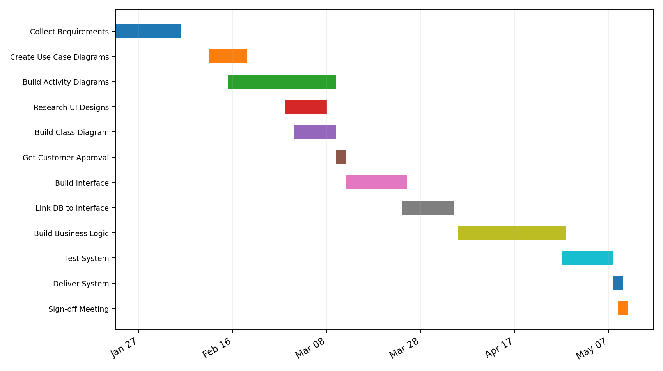

Source and AI Acknowledgment
Source: CS 255 DriverPass Interview Transcript (client interview and schedule planning); CS 255 Business Requirements Document Template. ChatGPT assisted in organizing a portfolio reconstruction from those materials. Review this document against your originally submitted Project One file and instructor feedback before treating it as your original course artifact.

